Bangladesh Medical Association (BMA)
List of Life Member-98
30. BMA Kishoreganj Branch

Sl No | Voter No | Voter Details
1 | Voter No  LM-3000001  No Image | DR. A. A. MAZHARUL HUQ  F/Name: Late Nawab Ali  M/Name:  BM & DC Reg. No:  NID:  Cell:  Address: Gouranga Bazar Kishoregonj  Blood Group:
2 | Voter No  LM-3000002  No Image | DR. MD. FAZLUL HAQ  F/Name: Late Dr. Dastur Ali  M/Name:  BM & DC Reg. No:  NID:  Cell:  Address: Akra Bazar, Kisoregonj  Blood Group:
3 | Voter No  LM-3000003  No Image | DR. LUKMAN ALI  F/Name: Late Lal Mohammad  M/Name:  BM & DC Reg. No:  NID:  Cell:  Address: Nishargha Goddhuli Nilgonj Road Kisoregonj.  Blood Group:
4 | Voter No  LM-3000004  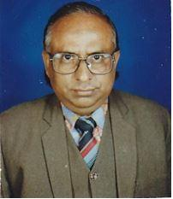 | DR. MD. SHAHEB ALI PATHAN  F/Name: Late Md. Abdul Halim Pathan  M/Name:  BM & DC Reg. No: 4076  NID:  Cell: 01711662802  Address: Shebangon, Station Road, Kishoreganj.  Blood Group:
5 | Voter No  LM-3000005  No Image | DR. MD. LUTFULLAH  F/Name: A. K. M. Sharfuddin Ahmed  M/Name:  BM & DC Reg. No:  NID:  Cell:  Address: Cresent Pharmacy, Puran Thana Kisoregonj.  Blood Group:
6 | Voter No  LM-3000006  No Image | DR. MD. SHAHIDUL HAQUE  F/Name:  M/Name:  BM & DC Reg. No:  NID:  Cell:  Address: Medical Officer Thana Health Complex Kisoregonj.  Blood Group:
7 | Voter No  LM-3000007  No Image | DR. MD. MAHABUB IQBAL  F/Name: Late Abdul Mannan  M/Name: Late Arzuda Begum  BM & DC Reg. No:  NID:  Cell: 01993410948  Address: P.O. Nayamatpur, Upazilla: Karimgonj Kisoregonj.  Blood Group:
8 | Voter No  LM-3000008  No Image | DR. MD. SIAZUDDIN  F/Name:  M/Name:  BM & DC Reg. No:  NID:  Cell:  Address:  Blood Group:  TRANSFERED to BMA Dhaka City  LM-1405543
9 | Voter No  LM-3000009  No Image | DR. MD. ATIQUL SARWAR  F/Name: Md. Bazlul Haque  M/Name:  BM & DC Reg. No:  NID:  Cell:  Address: Res. M.O, Sadar Hospital Kisoregonj.  Blood Group:
10 | Voter No  LM-3000010  No Image | DR. ABDUL HOQUE  F/Name: Late Hasen Uddin  M/Name:  BM & DC Reg. No:  NID:  Cell:  Address: THC, Sador Thana Kisoregonj  Blood Group:
11 | Voter No  LM-3000011  No Image | DR. MD. ALI AKBAR  F/Name: Abdul Halim Sarker  M/Name:  BM & DC Reg. No:  NID:  Cell:  Address: Sonalab Station Road Kisoregonj  Blood Group:
12 | Voter No  LM-3000012  No Image | DR. MD. LUTFUR RAHMAN KHAN  F/Name: Late Md. Elahi Newaz Khan  M/Name:  BM & DC Reg. No:  NID:  Cell:  Address: THC, Pakandia Kisoregonj  Blood Group:
13 | Voter No  LM-3000013  No Image | DR. MD. SIRAJUL HAQUE TALUKDER  F/Name: Safir Uddin Talukder  M/Name:  BM & DC Reg. No:  NID:  Cell:  Address:  Blood Group:
14 | Voter No  LM-3000014  No Image | DR. DEEN MOHAMMAD  F/Name: Lal Mohammad  M/Name:  BM & DC Reg. No:  NID:  Cell:  Address: TH & FPO, Tarail Kisoregonj  Blood Group:
15 | Voter No  LM-3000015  No Image | DR. CHANDRO SHEKORE BOSE  F/Name:  M/Name:  BM & DC Reg. No:  NID:  Cell:  Address: Trasnfered To Dhaka City LM--2870  Blood Group:  TRANSFERED to BMA Dhaka City  LM-1405543
16 | Voter No  LM-3000016  No Image | DR. MD. HATEM  F/Name: Md. Abdul Bari  M/Name:  BM & DC Reg. No:  NID:  Cell:  Address: TH & FPO, Bajetpur Kisoregonj  Blood Group:
17 | Voter No  LM-3000017  No Image | DR. MD. AFTAB UDDIN  F/Name:  M/Name:  BM & DC Reg. No:  NID:  Cell:  Address:  Blood Group:  TRANSFERED to BMA Dhaka City  LM-1405543
18 | Voter No  LM-3000018  No Image | DR. MD. ABDUL KHALEQUE CHAKDER  F/Name: Md. Imam Hossain Chakder  M/Name:  BM & DC Reg. No:  NID:  Cell:  Address: AD(CC) DFPO Kisoregonj  Blood Group:
19 | Voter No  LM-3000019  No Image | DR. MAHMUD HASAN  F/Name:  M/Name:  BM & DC Reg. No:  NID:  Cell:  Address:  Blood Group:  TRANSFERED to BMA Dhaka City  LM-1405543
20 | Voter No  LM-3000020  No Image | DR. MD. NAZRUL ISLAM  F/Name: Late Mofizuddin Ahmed  M/Name:  BM & DC Reg. No:  NID:  Cell:  Address: TH & FPO, Katiadi Kisoregonj  Blood Group:
21 | Voter No  LM-3000021  No Image | DR. MD. ABDUL MUKTADIR BHUIYAN  F/Name: Md. Abdul Halim Bhuiyan  M/Name:  BM & DC Reg. No:  NID:  Cell:  Address: RMO, TH & FPO, Katiadi Kisoregonj  Blood Group:
22 | Voter No  LM-3000022  No Image | DR. MD. ISRAIL HUSSAIN  F/Name: Md. Sabel Ali  M/Name:  BM & DC Reg. No:  NID:  Cell:  Address: M.O., T.H.C , Sadar Hospital Kisoregonj  Blood Group:
23 | Voter No  LM-3000023  No Image | DR. SAKTI PROSHAD BANIK  F/Name: Sachindra Kumar Banik  M/Name:  BM & DC Reg. No:  NID:  Cell:  Address: MO(MCH-FP) Bajetpur Kisoregonj  Blood Group:
24 | Voter No  LM-3000024  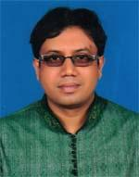 | DR. MOHAMMAD MIZANUR RAHMAN  F/Name: Moyez Uddin Ahmed  M/Name: Razia Khatun  BM & DC Reg. No: 38724  NID: 4821104671445  Cell: 01718167646  Address: Nobi Pharmacy, Bhairab, Kishoregonj  Blood Group: B+
25 | Voter No  LM-3000024  No Image | DR. S. N. E HANGSU MOHAN SAHA ROY  F/Name: Late Radhika Mohan Saha Roy  M/Name:  BM & DC Reg. No:  NID:  Cell:  Address: THC, Katiadi Kisoregonj.  Blood Group:
26 | Voter No  LM-3000025  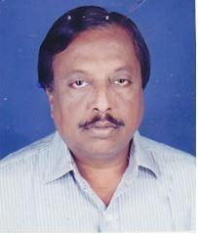 | DR. MD. AZHARUL ISLAM  F/Name: Late Akhter Uddin Ahmed  M/Name:  BM & DC Reg. No:  NID:  Cell:  Address: M.O. Civil Surgon Kisoregonj  Blood Group:
27 | Voter No  LM-3000026  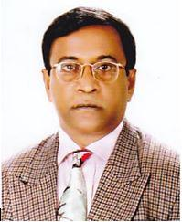 | DR. A. N. M. NAUSHAD KHAN  F/Name: Abdul Halim Khan  M/Name:  BM & DC Reg. No:  NID:  Cell:  Address: M.O. Sador Thana Kisoregonj  Blood Group:
28 | Voter No  LM-3000027  No Image | DR. CHAYAN SAHA ROY  F/Name: Kumud Chandra Saha Roy  M/Name:  BM & DC Reg. No:  NID:  Cell:  Address: M.O. Katiadi Kisoregonj  Blood Group:
29 | Voter No  LM-3000028  No Image | DR. MD. ABDUL HAMID  F/Name: Md. Mizanur Rahman  M/Name:  BM & DC Reg. No:  NID:  Cell:  Address: THC, Karimgonj Kisoregonj  Blood Group:
30 | Voter No  LM-3000029  No Image | DR. MD. GOLAM KABIR  F/Name: Md. Abdul Quddus Bhuiyan  M/Name:  BM & DC Reg. No:  NID:  Cell:  Address: THC, Karimgonj Kisoregonj  Blood Group:
31 | Voter No  LM-3000030  No Image | DR. SANDIP DUTTA ROY  F/Name: Sukhender Nath Roy  M/Name:  BM & DC Reg. No:  NID:  Cell:  Address: RMO, THC, Nikalee Kisoregonj  Blood Group:
32 | Voter No  LM-3000031  No Image | DR. SYED MD. MANJURUL HOQUE  F/Name: Syed Md. Mujibul Hoque  M/Name:  BM & DC Reg. No:  NID:  Cell:  Address: RMO, THC, Nikalee Kisoregonj  Blood Group:
33 | Voter No  LM-3000032  No Image | DR. MD. SHADAT KABIR MUKUL  F/Name: Late Md. Mir Hossain  M/Name:  BM & DC Reg. No:  NID:  Cell:  Address: Humy Dew Rest Hosuse , Bottala Kisoregonj  Blood Group:
34 | Voter No  LM-3000033  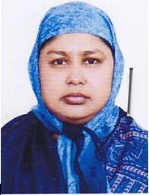 | DR. SUFIA KHATUN  F/Name: Abdus Sattar Fakir  M/Name:  BM & DC Reg. No:  NID:  Cell:  Address: 528, Kharampatty Kisoregonj  Blood Group:
35 | Voter No  LM-3000034  No Image | DR. MD. HABIBUR RAHMAN  F/Name: Khurshed Uddin Ahmed  M/Name:  BM & DC Reg. No:  NID:  Cell:  Address: MD(CC) DFPO Kisoregonj  Blood Group:
36 | Voter No  LM-3000035  No Image | DR. MD. AMZAD HOSSAIN KHAN  F/Name: Md. Firoj Miah  M/Name:  BM & DC Reg. No:  NID:  Cell:  Address:  Blood Group:
37 | Voter No  LM-3000036  No Image | DR. MD. ABUL KASHEM AZAD  F/Name:  M/Name:  BM & DC Reg. No:  NID:  Cell:  Address:  Blood Group:  TRANSFERED to BMA Dhaka City  LM-1405543
38 | Voter No  LM-3000037  No Image | DR. SHAHERA BEGUM  F/Name: Md. Nurul Huq  M/Name:  BM & DC Reg. No:  NID:  Cell:  Address: M.O. MCHP, Vairab Kisoregonj  Blood Group:
39 | Voter No  LM-3000038  No Image | DR. MD. HELAL UDDIN  F/Name: Md. Fazlul Hoque  M/Name:  BM & DC Reg. No:  NID:  Cell:  Address: M.O. MCHP, Karimgonj Kisoregonj  Blood Group:
40 | Voter No  LM-3000039  No Image | DR. NAIMUN NESA BEGUM  F/Name: Late Abdul Quyum Khan  M/Name:  BM & DC Reg. No:  NID:  Cell:  Address: THC, Katiadi Kisoregonj  Blood Group:
41 | Voter No  LM-3000040  No Image | DR. HALIMA AKHTER  F/Name: Md. Abdus Samad  M/Name:  BM & DC Reg. No:  NID:  Cell:  Address: MO(MCH-FP) Hossainpur Kisoregonj  Blood Group:
42 | Voter No  LM-3000041  No Image | DR. MUHAMMAD SHIBBIR AHMED  F/Name:  M/Name:  BM & DC Reg. No:  NID:  Cell:  Address:  Blood Group:  TRANSFERED to BMA Dhaka City  LM-1405543
43 | Voter No  LM-3000042  No Image | DR. MD. MOSHARROF HOSSAIN  F/Name: Md. Belayed Hossain  M/Name:  BM & DC Reg. No:  NID:  Cell:  Address: Reg. Eye Dept., JIMCH, Bajayetpur Kisoregonj  Blood Group:
44 | Voter No  LM-3000043  No Image | DR. A.T.M. YUSUF HAROON  F/Name: Shaheed M. Abdul Ali  M/Name:  BM & DC Reg. No:  NID:  Cell:  Address: Asst. Prof. Dept. Of Surgery, JIMCH Kisoregonj  Blood Group:
45 | Voter No  LM-3000044  No Image | DR. MD. JAHIRUL ISLAM  F/Name:  M/Name:  BM & DC Reg. No:  NID:  Cell:  Address: Eidgah Road Solakia Kisoregonj  Blood Group:
46 | Voter No  LM-3000045  No Image | DR. MD. AMINUL HAQUE AKHANDA  F/Name:  M/Name:  BM & DC Reg. No:  NID:  Cell:  Address: Eye Specialist Sadar Hospital, Kisoregonj.  Blood Group:
47 | Voter No  LM-3000046  No Image | DR. MD. MASHIUR RAHMAN  F/Name: Late Islam Uddin  M/Name:  BM & DC Reg. No:  NID:  Cell:  Address: Z.. Islam Medical Collage Hospital Bhagalpur, Bajetpur Kisoregonj.  Blood Group:
48 | Voter No  LM-3000047  No Image | DR. A.K.M. ABDUS SATTER  F/Name:  M/Name:  BM & DC Reg. No:  NID:  Cell:  Address: Z. Islam Medical Collage Hospital Bhagalpur Bajetpur, Kisoregonj.  Blood Group:
49 | Voter No  LM-3000048  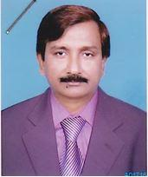 | DR. MOHAMMAD MOHSIN  F/Name: Md. Husain Ali.  M/Name:  BM & DC Reg. No:  NID:  Cell:  Address: Junior Consultant (Child) Adhunik Sadar Hospital, Kisoregonj.  Blood Group: A+
50 | Voter No  LM-3000049  No Image | DR. A.B.M. AZIZUL ISLAM  F/Name:  M/Name:  BM & DC Reg. No:  NID:  Cell:  Address: a  Blood Group:
51 | Voter No  LM-3000050  No Image | DR. MD. MONZUR-UL-KARIM KHAN  F/Name:  M/Name:  BM & DC Reg. No:  NID:  Cell:  Address:  Blood Group:
52 | Voter No  LM-3000051  No Image | DR. SAEDUR RAHMAN  F/Name:  M/Name:  BM & DC Reg. No:  NID:  Cell:  Address: Prof. of Paediatrics, Jahurul Islam Medical College Hospital, Dhaka.  Blood Group:
53 | Voter No  LM-3000052  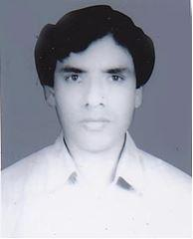 | DR. DR. ASHRAF UDDIN  F/Name: Md. Salim Uddin  M/Name:  BM & DC Reg. No:  NID:  Cell:  Address: 1286, Tanika Mansion, Tonka G. Hosp. Kisoregonj  Blood Group:
54 | Voter No  LM-3000053  No Image | DR. MUHI UDDIN AHMED  F/Name: Late Mafiz Uddin Ahmed  M/Name:  BM & DC Reg. No:  NID:  Cell:  Address: 683 Kazi Nazrul Islam By Road Kisoregonj  Blood Group:
55 | Voter No  LM-3000054  No Image | DR. MD. JAHIRUL ISLAM  F/Name: Late Abdul Bari Siddique  M/Name:  BM & DC Reg. No:  NID:  Cell:  Address: Eidgah Road, Solakia, Kisoregonj.  Blood Group:
56 | Voter No  LM-3000055  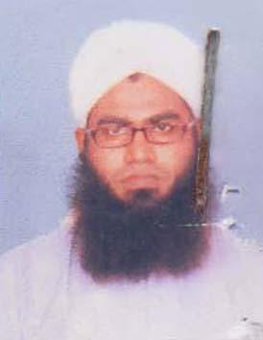 | DR. MOHAMMAD SHAJIBUL ISLAM  F/Name: Late Mohammad Shahabuddin  M/Name: Mrs. Rabia Akhter Khatun  BM & DC Reg. No: 42864  NID: 2691649421701  Cell: 01711604777  Address: Chad Palace (1st Floor), Kharampott, Kishoreganj  Blood Group: AB_po
57 | Voter No  LM-3000056  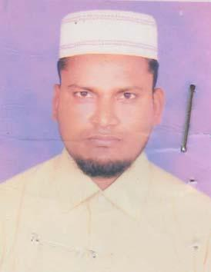 | DR. MOHAMMAD SHAFIUL ALAM  F/Name: Md. Rais Uddin  M/Name: Mrs. Rahima Khuton  BM & DC Reg. No: 36085  NID: 4814969161275  Cell: 01671327056  Address: Shreenagor Old Court Road, Kishoreganj  Blood Group: B+
58 | Voter No  LM-3000057  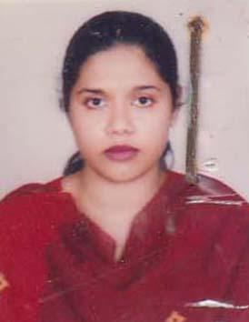 | DR. TASNIN SULTANA  F/Name: Md. Idrish Ali  M/Name: Mrs. Noorjahan Begum  BM & DC Reg. No: 43822  NID: 4814969161206  Cell: 01711940961  Address: Shreenagor Old Court Road, Kishoreganj  Blood Group: O+
59 | Voter No  LM-3000058  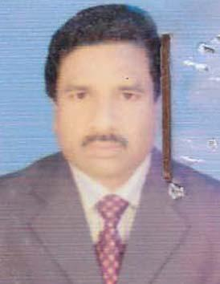 | DR. SASHANKA KUMAR SUTRADHAR  F/Name: Late Dr. Satish Chandra Sutradhar  M/Name: Shanti Lata Sutradhar  BM & DC Reg. No: 15909  NID: 4824903312140  Cell: 01711683207  Address: Adhunik Sadar Hospital, Kishoregonj  Blood Group: O+
60 | Voter No  LM-3000059  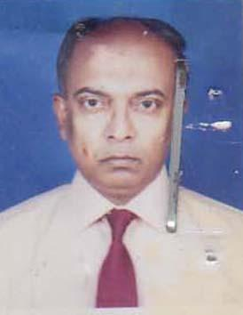 | MOLLA NAZRUL ISLAM  F/Name: Late. Molla Yousuf Ali  M/Name: Mrs. Morium Begum  BM & DC Reg. No: 16200  NID: 4824903312914  Cell: 01711420373  Address: Junior Consultant Surgery, Adunik Sadar Hospital, Kishoreganj  Blood Group: B+
61 | Voter No  LM-3000060  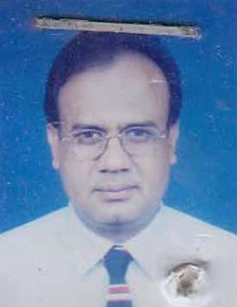 | DR. MD. ABU TAHER  F/Name: Late M.a. Taleb  M/Name: Late Ajofa Begum  BM & DC Reg. No: 13123  NID: 4824909355235  Cell: 01714029564  Address: Junior Consultant Cardiology (CC) Sadar Hospital, Kishoregonj  Blood Group: A+
62 | Voter No  LM-3000061 | DR. MOHAMMAD ABDUL WAHAB (BADAL)  F/Name: Late Mohammad Ain Uddin Sarkar  M/Name: Mrs Sayeda Khatun  BM & DC Reg. No: 32213  NID: 4824906329747  Cell: 01711239690  Address: 1146, Sarkari Pukur Par, Kharampotti, Kishoregonj  Blood Group: O+
63 | Voter No  LM-3000062  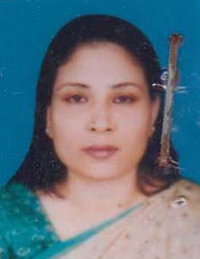 | DR. RAWSHAN AKHTER JAHAN  F/Name: SK. Ahmed Hossain  M/Name: Begum Akhter Tahan  BM & DC Reg. No: 44709  NID: 4824905322217  Cell: 01716365288  Address: Barnali, Harua, Kishoreganj  Blood Group: B+
64 | Voter No  LM-3000063  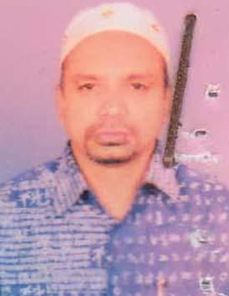 | DR. MD. ABU TAHER MEAN  F/Name: L. Abdul Hye Bepari  M/Name: Fatema Begum  BM & DC Reg. No: 18779  NID: 2695434704764  Cell: 01711606760  Address: Medilab Health Centre, Station Road, Kishoregonj-2300  Blood Group: B+
65 | Voter No  LM-3000064  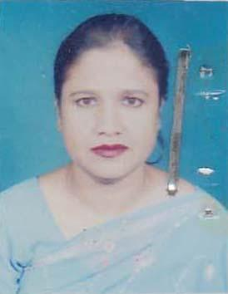 | DR. SULTANA RAZEA  F/Name: Late Md. Mohi Uddin  M/Name: Late Julekha Khatun  BM & DC Reg. No: 28722  NID: 4824901300637  Cell: 01712564606  Address: Medical Officer, Adhunik Sadar Hospital, Kishoregonj  Blood Group: A+
66 | Voter No  LM-3000065  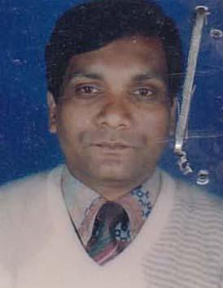 | DR. MD. GOLAM FARUQUE  F/Name: Md. Abdul Latif (Late)  M/Name: Mst. Amena Khatun  BM & DC Reg. No: 28723  NID: 4824901300636  Cell: 01712080727  Address: Medical Officer, Adhunik Sadar Hospital, Kishoregonj  Blood Group: B+
67 | Voter No  LM-3000066  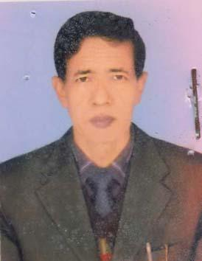 | DR. MD. RAMJAN MAHMUD  F/Name: Late Md. Sirajul Haque  M/Name: Late Meherun Netcha  BM & DC Reg. No: 35699  NID: 4824901300465  Cell: 01715054215  Address: C.D.C. Kishoregong  Blood Group: O+
68 | Voter No  LM-3000067  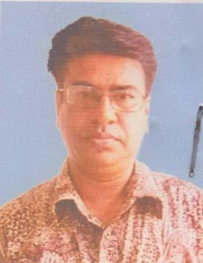 | DR. MD. AHSANUL HAQUE MUKUL  F/Name: Late Abu Bakar Siddique  M/Name: Late- Amena Khatun Chowdhury  BM & DC Reg. No: 19486  NID: 4824905326473  Cell: 01820067488  Address: UHCFPO, Nikli, Kishorgonj  Blood Group: O+
69 | Voter No  LM-3000068  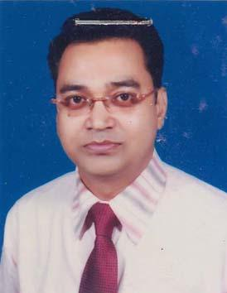 | DR. HARE KRISHNA DEBNATH  F/Name: Sashi Mohan Debnath  M/Name: Parul Debnath  BM & DC Reg. No: 28094  NID: 4824902307039  Cell: 01711186207  Address: Medical Officer, Uphcp, Municipality, Kishoregonj  Blood Group: B+
70 | Voter No  LM-3000069  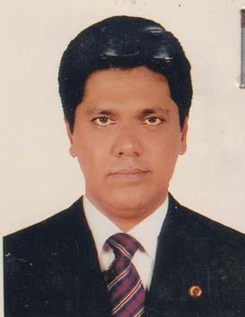 | DR. BULBUL AHMAD  F/Name: Late- Abdul Azizz  M/Name: Late- Banecha Khatun  BM & DC Reg. No: 40424  NID: 4815999892002  Cell: 01711147295  Address: MAA O Shisu General Hospital Komoipur,  Blood Group:
71 | Voter No  LM-3000070  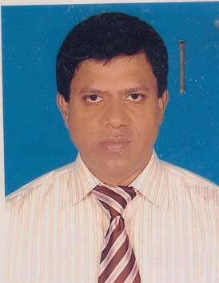 | DR. HARIPADA DEB NATH  F/Name: Late Atul Chandra Deb Nath  M/Name: Bina Deb Nath  BM & DC Reg. No: 20088  NID: 482108695788  Cell: 01711067271  Address: Upazilla Health Complex, Pohairab, Kishoreganj  Blood Group: A+
72 | Voter No  LM-3000071  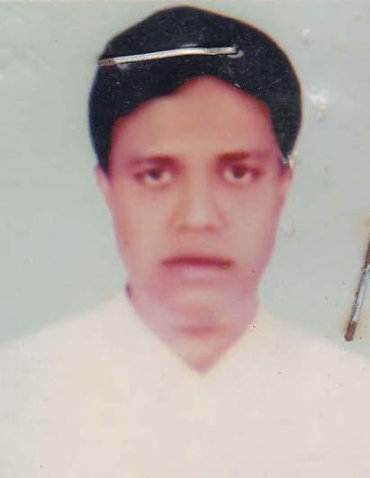 | DR. MD. TAUHIDUL ISLAM  F/Name: Abdul Khaleque  M/Name: Lutfunnahar  BM & DC Reg. No: 32925  NID: 6826302107484  Cell: 01748921218  Address: 8, Selim House, Komolapur, Bhairab, Kishoregonj  Blood Group: O+
73 | Voter No  LM-3000072  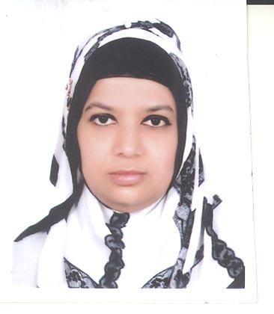 | DR. TASLIMA HAQUE  F/Name: Late, Abdur Rahim  M/Name: Mrs: Hosneara Khatun  BM & DC Reg. No: 18468  NID: 4821104674575  Cell: 01711523969  Address: House #15. C-2, Road # 07, (Dynesty), Gulshan, Dhaka  Blood Group: O+
74 | Voter No  LM-3000073  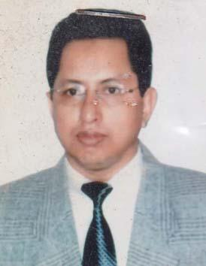 | DR. MD. AZIZUL HAQUE  F/Name: Late. Alhaj, Dr. Md. Sirajul Islam  M/Name: Mrs. Anwara Islam  BM & DC Reg. No: 15469  NID: 4821104674574  Cell: 01199437160  Address: House # 15, C-2, Road # 07, (Dynesty), Gulshan-1, Dhaka  Blood Group: O+
75 | Voter No  LM-3000074  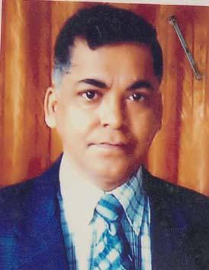 | DR. MD. MOMTAZUL HOQUE  F/Name: Late Haji Abdul Latif  M/Name: Late, Haji Momena Khatun  BM & DC Reg. No: 14720  NID: 4821109698428  Cell: 01190349280  Address: UHFPO, UPZ, Bhairab, Kishoreganj  Blood Group:
76 | Voter No  LM-3000075  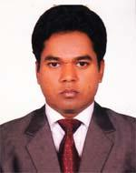 | DR. NAZMUL HASAN BHUIYAN  F/Name: Idris Bhuiyan  M/Name: Jesmin Begum  BM & DC Reg. No: 49652  NID: 4810247729864  Cell: 01716030316  Address: New Doctors Quarter, 250 Beded District Hospital, Kishoregonj  Blood Group: B+
77 | Voter No  LM-3000076  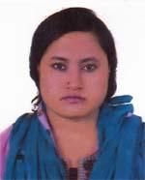 | DR. MAHAMUDA AKTER  F/Name: Md. Azgar Ali  M/Name: Bedena Begum  BM & DC Reg. No: 53697  NID: 2692846958459  Cell: 01723573733  Address: New Doctors Quarter, 250 Beded District Hospital, Kishoregonj  Blood Group: O+
78 | Voter No  LM-3000077 | DR. ABU SALEH MD. EKRAM UDDIN  F/Name: Late Janab Solaiman Bodsha  M/Name: Late Janab Momtaz Begum  BM & DC Reg. No: 15547  NID: 2694813863825  Cell: 01771110415  Address: Junior Consultant, CDC, Kishoregonj  Blood Group: B+
79 | Voter No  LM-3000078  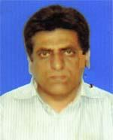 | DR. SYED KHAWAJA MASUDUZZAMAN  F/Name: Late Syed Khawaja Sahidullah  M/Name: Fazilatunnessa Begum  BM & DC Reg. No: 29322  NID:  Cell: 01711227991  Address: A-89 Hospital Quarter, Sadar Hospital, Kishoregonj  Blood Group: B+
80 | Voter No  LM-3000079 | DR. SUSHIL KUMAR SHIL  F/Name: Santi Ranjan Shil  M/Name: Bakul Bala Shil  BM & DC Reg. No: 26906  NID: 4824903312278  Cell: 01711139267  Address: Chhaya Prosthe, 206/1, Kharampatti, Kishoregonj  Blood Group: B+
81 | Voter No  LM-3000080  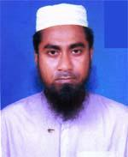 | DR. MOHAMMED MANSUROL HAQUE  F/Name: Md. Aymul Haque  M/Name: Mts. Rowson Ara Haque  BM & DC Reg. No: 43192  NID: 4819294801577  Cell: 01914857552  Address: Okil Para, Kishoregonj  Blood Group: O+
82 | Voter No  LM-3000081  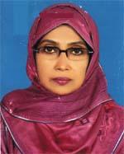 | DR. NAHID SATTAR  F/Name: Md. Abdus Sattar  M/Name: Mrs. Rezia Begum  BM & DC Reg. No: 21927  NID: 6125203665927  Cell: 01715120829  Address: Hoybath Nagor, Kishoregonj  Blood Group: A+
83 | Voter No  LM-3000082  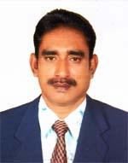 | DR. JASHODA DULAL SAHA  F/Name: Sachindra Mohan Saha  M/Name: Gita Rani Saha  BM & DC Reg. No: 20638  NID: 33183285951464  Cell: 01711947726  Address: MCWC Sadar, Kishoregonj  Blood Group: AB+
84 | Voter No  LM-3000083  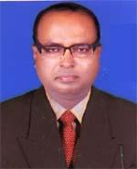 | DR. HALISH RANJEN SARKER  F/Name: Nikhil Chandra Sarker  M/Name: Late Bela Rani Sarker  BM & DC Reg. No: 25781  NID: 4820603418508  Cell: 01710835387  Address: Upazilla Health Complex, Bajitpur, Kishoreganj  Blood Group: O+
85 | Voter No  LM-3000084  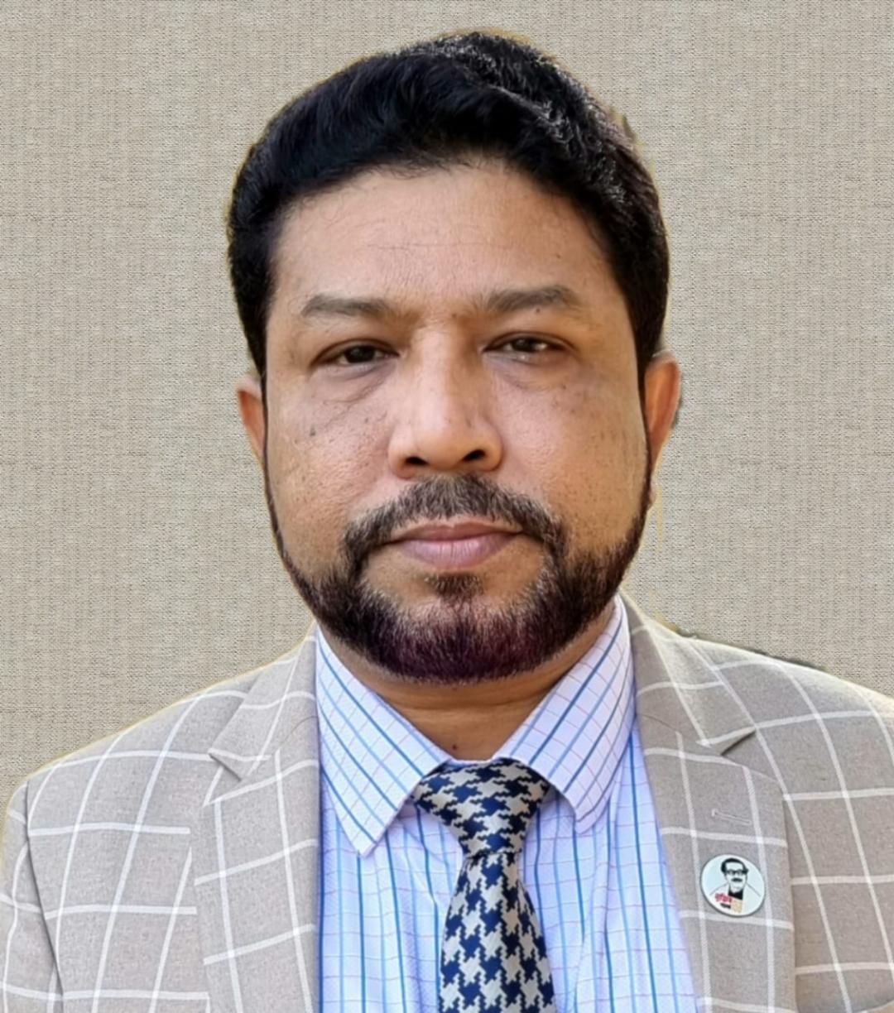 | DR.MD.MUJIBUR RAHMAN  F/Name: Late Ashek Ali Akanda  M/Name: Mrs. Jahan Ara Begum  BM & DC Reg. No: 28608  NID: 2611038870300  Cell: 01715046140  Address: B/2 Uttara Road, Nogua, Kishoregonj  Blood Group: B+
86 | Voter No  LM-3000085  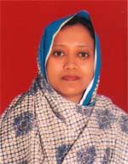 | DR. TASLIM ARA NILA  F/Name: Safir Uddin Ahmed  M/Name: Hosne Ara Begum  BM & DC Reg. No: 30822  NID: 2611038868892  Cell: 01715303483  Address: B/2 Uttara Road, Nogua, Kishoregonj  Blood Group: B+
87 | Voter No  LM-3000086  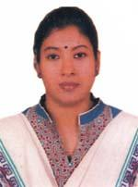 | DR. ZENAT RAIHANA  F/Name: Md. Enayet Uddin Khan  M/Name: Shahana Begum  BM & DC Reg. No: 46970  NID: 19836125214208095  Cell: 01914857929  Address: Upazilla Health Complex, Tarail, Kishoregonj  Blood Group: O+
88 | Voter No  LM-3000087  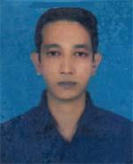 | DR. MD. BADRUL HASSAN  F/Name: Md. Obaidur Rahman  M/Name: Late Hasna Hena  BM & DC Reg. No: 47973  NID: 6125214204461  Cell: 01925950801  Address: Upazilla Health Complex, Tarail, Kishoregonj  Blood Group: O+
89 | Voter No  LM-3000088  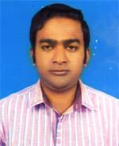 | DR. MD. AZHARUL ISLAM  F/Name: Md. Nurul Islam  M/Name: Razia Akter  BM & DC Reg. No: 57825  NID: 4824907491604  Cell: 01719072143  Address: Upazilla Health Complex, Tarail, Kishoregonj  Blood Group: AB+
90 | Voter No  LM-3000089  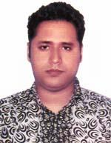 | DR. MOHAMMAD SHADIK HOSSAIN  F/Name: Md. Siddiqure Hossain Sarker  M/Name: Mrs. Dil Asa Akhter  BM & DC Reg. No: 55182  NID: 2699501912180  Cell: 01920073273  Address: 138, New Town, Kishoreganj  Blood Group: B+
91 | Voter No  LM-3000090  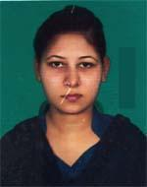 | DR. TABASSUM TAJRIN BINTY ALAM  F/Name: Shah Alam Talukder  M/Name: Meshgan Mahal Siddiqua  BM & DC Reg. No: 66778  NID: 19909319400037793  Cell: 01676336550  Address: 138, New Town, Kishoreganj.  Blood Group: A+
92 | Voter No  LM-3000091  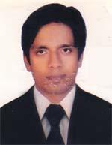 | DR. MUHAMMAD TAUFIQUR RAHMAN  F/Name: Late Md. Mojibur Rahman  M/Name: Mrs. Shamsunnahar  BM & DC Reg. No: 46122  NID: 4525315721210  Cell: 01712905693  Address: 4032, Fatema Monjeel, Kharam Potty, Kishoreganj  Blood Group: B+
93 | Voter No  LM-3000092  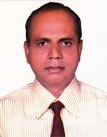 | DR. MD. ABDUL HAI  F/Name: Late Md. Abdul Jabbar  M/Name: Late Mrs. Johura Akther  BM & DC Reg. No: 22253  NID: 4824907337217  Cell: 01727171965  Address: NRV Clinic, Ishak Plaza, Puranthana, Kishoreganj  Blood Group: AB+
94 | Voter No  LM-3000093 | DR. MOHAMMAD MIZANUR RAHMAN  F/Name: Moyez Uddin Ahmed  M/Name: Razia Khatun  BM & DC Reg. No: 38724  NID: 4821104671445  Cell: 01718167646  Address: Nobi Pharmacy, Bhairab Kishoreganj.  Blood Group: B+
95 | Voter No  LM-3000094  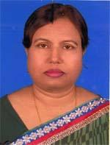 | DR. HUSNA BEGUM  F/Name: Late Ausaf Uddin Ahmed  M/Name: Late Mahfuja Ahmed  BM & DC Reg. No: 21524  NID: 48249033114816  Cell: 01711353967  Address: 1182, Kharam Patti, Kishoregonj  Blood Group: A+
96 | Voter No  LM-3000095 | DR. MD. BENZAMIN  F/Name: Md. Nazrul Islam  M/Name: Rebeka Sultana  BM & DC Reg. No: 57029  NID: 4811183640702  Cell: 01719183948  Address: House No. 330, Rofiqul Islam Mohila College Road, Bhairabpur, Bhairab  Blood Group: B+
97 | Voter No  LM-3000096 | DR. MD. TANVIR HASAN  F/Name: Md. Zahedul Alam  M/Name: Mst. Jahanara Akther Khanom  BM & DC Reg. No: 51734  NID: 19844812713404981  Cell: 01716598735  Address: Doctors Quarter,(Golap) Upazilla Health Complex, Hossainpur, Kishoregonj  Blood Group: A+
98 | Voter No  LM-3000097 | DR. TANZINA HAQUE SHAWON  F/Name: Mohd. Ashanul Haque  M/Name: Sultana Jesmin  BM & DC Reg. No: 74003  NID: 19914824905000049  Cell: 01748098105  Address: 283, Nabadhara, Bismillah Masjid Road, Harua, kishoregonj  Blood Group: O+

